Aktuelt fra Island
Nordisk redningskonference i Vaasa, Finland 2009

Ágúst Gunnar Gylfason, Project Manager
Department of Civil Protection and Emergency Management
National Commissioner of Police

The purpose of this paper is to give a short overview of major developments in Iceland since we had the last NORDRED conference in Reykjavík in 2006.
First of all there is an overview of new legislation on Civil Protection which was passed in May 2008. Then there is some information about an earthquake in Southern Iceland which occurred on May 29th 2008 and lastly there is an overview of our work on a response plan for pandemic influenza in Iceland.
New Civil Protection Act
At the end of May last year the Icelandic Parliament passed new legislation on Civil Protection. This legislation had been in the pipelines for nearly four years and the work was kicked off with a conference where stakeholders discussed their views of Civil Protection. The discussions at the conference were used as input into the legislation and
stakeholders had been given an opportunity to input their views on the proposed legislation.
This new legislation is very much in the same spirit as recent legislation on Civil Protection in the other Nordic countries. The main purpose of the legislation is to ensure that necessary measures are taken to ensure the safety and well being of the general public as well as insure that all branches of government and the private sector keep functioning in case of catastrophic events or other emergencies.
This new legislation provides a renewed and expanded basis for Civil Protection at both national and local level to study hazards and risks; educate the public and other relevant bodies about hazards and risks and how to respond to such risks; devise and implement mitigation measures and finally to devise contingency plans where those are relevant.
The new Civil Protection Act stipulates the formation of a Civil Protection and Security Council to be formed at the highest level of government. The council is chaired by the Prime Minister. Other members of the Council include the ministers of justice, foreign affairs, communications, environment and industry. The Prime Minister may co-opt to call on additional ministers to join the council. The permanent secretaries of the above ministries also have a seat on the Council for Civil Protection and Security. In addition to the cabinet ministers and permanent secretaries the council is made up of a number of government officials and representatives from non-governmental organisations. These include the National commissioner of Police, the directors of the Coast Guard, the Civil Aviation Authority, the Post and Telecommunications administration, the Icelandic Road Administration, the Environmental Agency, the Fire Authority, the Meteorological Office, The Medical director of Health, The State Epidemiologist, the director of the Radiation protection Institute as well as the director of the National Energy Authority and the Power Transmission Company.
In addition to these there are representatives from the Icelandic Search and Rescue Teams, the Red Cross, the 112 Emergency Call Centre and two representatives of the Association of Local Authorities.
The Council draws up the policy on matters regarding civil protection and security for three years at a time.
The Minister of Justice is responsible for administrative matters concerning the Civil Protection and Security Council.
The Minister of Justice is the supreme authority on matters of Civil Protection. The National Commissioner of Police is responsible for day to day operations of Civil Protection and he does so through the Department of Civil Protection and Emergency Management. These daily tasks include ensuring that Civil Protection Policy is carried out at both the national and local level. The Department of Civil Protection and Emergency Management supervises risk assessments, participates in the preparation of contingency plans at both the national and local level. We provide other authorities with templates for their plans and we assume the role of editors or project managers for that work. The purpose is to have uniform plans, as far as possible, for different types of hazards or emergencies. The Department of Civil Protection and Emergency Management is also responsible for disseminating information about hazards and risks, that is to say it is our responsibility to educate the general public as well as selected groups. A point in case would be the courses we run in co-operation with the Police College, the school for the volunteer SAR teams and the fire fighters school to educate on-scene commanders and people who work in District Operational Commands.
The National Commissioner of Police also supervises the co-ordination of response units. We also run a Joint Rescue Command Centre for Iceland which is used to co-ordinate operations in Civil Protection operations and also in searches for missing persons. The JRCC can also function as a command centre for searches for missing aircraft or vessels lost at sea.
Civil Protection at the local level is made up of two pillars so to speak. On the one hand we have Civil Protection Committees appointed by local government. The committees work on local Civil Protection policy, do risk assessments and contingency planning and take part in testing those plans. In addition they appoint a representative to work in the District Operational Command. They also have a great role in rebuilding society after disasters strike.
On the other hand we have the District Commissioners of Police who sit on the local Civil Protection Committees in addition to being in charge of the District Operational Command and appointing on-scene commanders.

Earthquake in southern Iceland May 29th 2008
On May 29th 2008, at 15:45 in the afternoon there was an earthquake measuring 6.3 on the Richter scale. In fact it was an earthquake similar to the one in Italy earlier this year. The Epicentre was about 3 km from Hveragerði with a population of about 2.300, about t10 km from Selfoss with 6.300 inhabitants and around 15 km from Þorlákshöfn with 1.500 inhabitants.
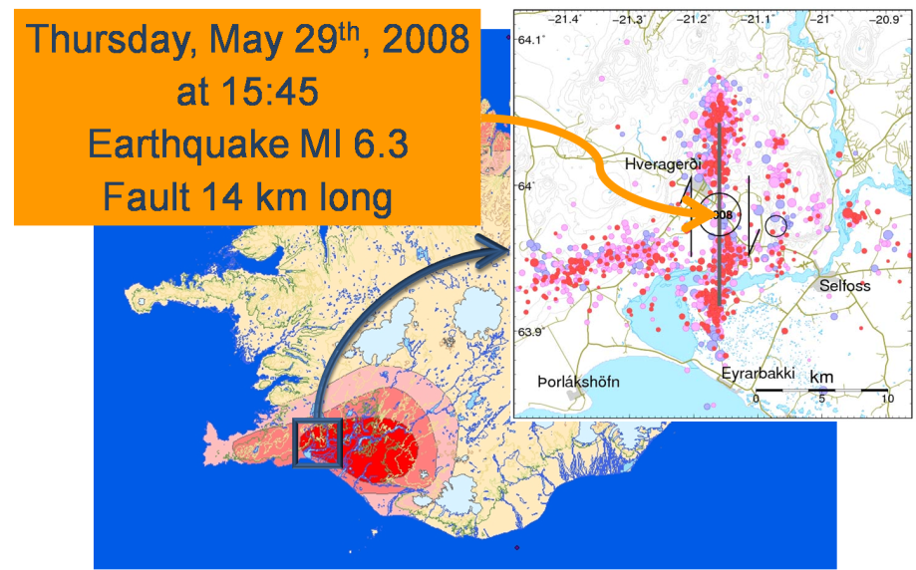
Figure 1 The red Zone on the map shows the area most prone to strong earthquakes in Iceland. In that area we can expect earthquakes on the scale of 6.5 to 7+. Note the Towns of Hveragerði, Selfoss and Þorlákshöfn.

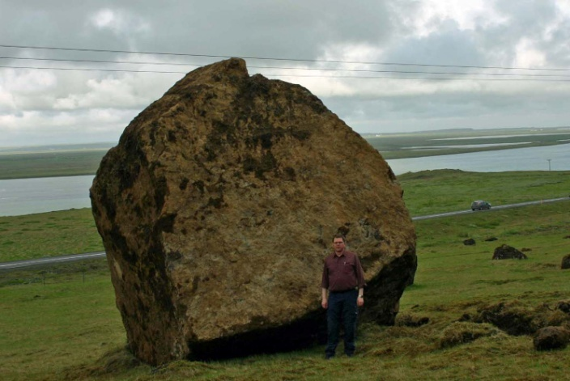
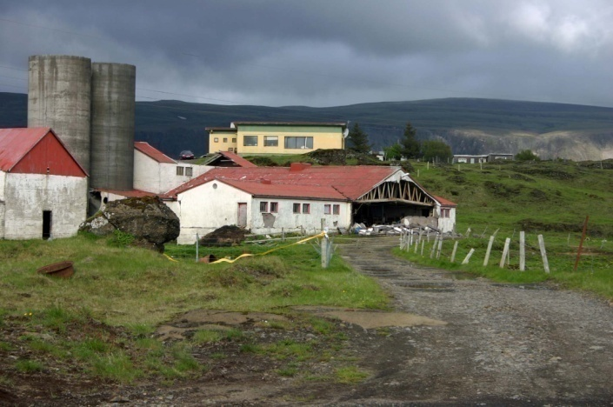
Here is where we start seeing differences between Iceland and Italy. We had no deaths, only one major injury, a hip fracture, and only 36 minor injuries such as broken arms. As far as the population goes trauma was the most difficult to deal with. The Red Cross offered psychological first aid immediately after the earthquake but the University hospital took over psychological aid after that. Studies have shown that a lot of trauma is still underlying and surfaces in consultations with health professionals about unrelated matters.
Figure 2 Partially collapsed farm buildings near Hveragerði, note that the gable of the building has collapsed and the walls are severely cracked. Photo: Ágúst Gunnar Gylfason.
There was widespread property damage during the earthquake. A few buildings collapsed partly, none of these were homes or public buildings. Most were barns or stables. A few homes were judged unfit for repairs and were subsequently demolished.
Figure 3 A boulder of about 100 tons which travelled bout 400 meters downhill and then about 100 meters away from the bottom of the slope. Photo Ágúst Gunnar Gylfason.
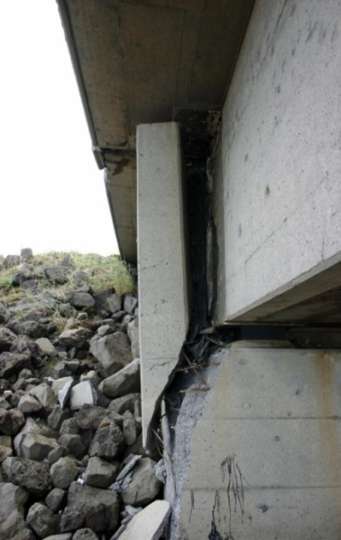
There have been 3.272 reports of damage to buildings and other structures and 2.451 reports of damage to household inventory such as furniture, cabinets and appliances. Compensation will probably exceed 6 billion ISKR. 3.8 billion have been approved for buildings, close to 1 billion ISKR for household inventory and a further 1.5 billion ISKR is expected to be paid out on both accounts.
Figure 4 Minor structural damage to a bridge near Þorlákshöfn. Photo: Ágúst Gunnar Gylfason.
Immediately after the earthquake the government allocated 100 million ISKR for immediate rescue and relief expenses and an additional 700 million ISKR have been paid out by the government to people who were underinsured in some way.
Immediately after the earthquake the Department of Civil Protection and Emergency Management opened a service centre in cooperation with the State Natural Catastrophe Insurance Fund. At the service centre people could file insurance claims, report losses and seek advice on how to proceed with rebuilding their homes. In the initial weeks after the earthquake people could also seek trauma relief. Our new Civil Protection legislation allows for opening a service centre of this sort.
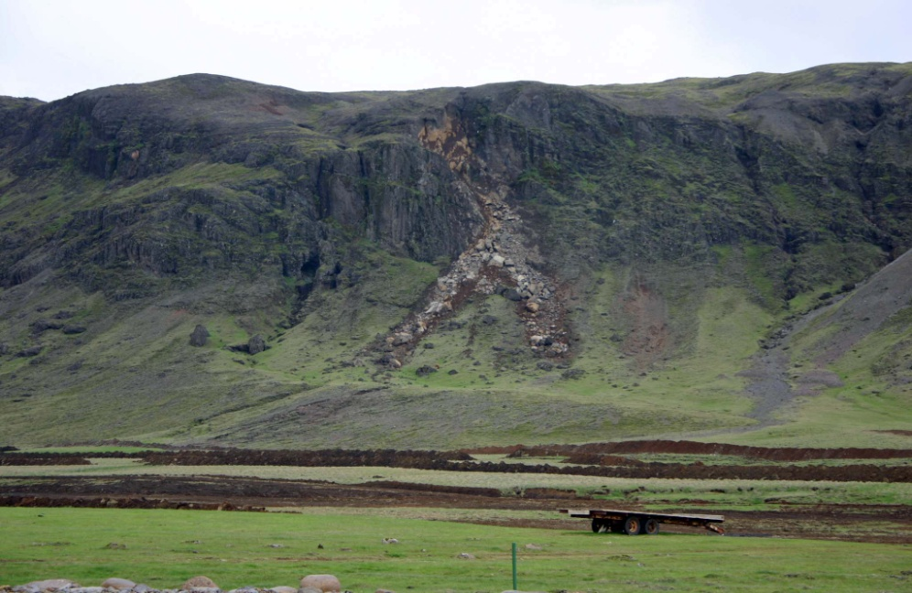
Figure 5 A rock slide near Hveragerði. Photo: Ágúst Gunnar Gylfason

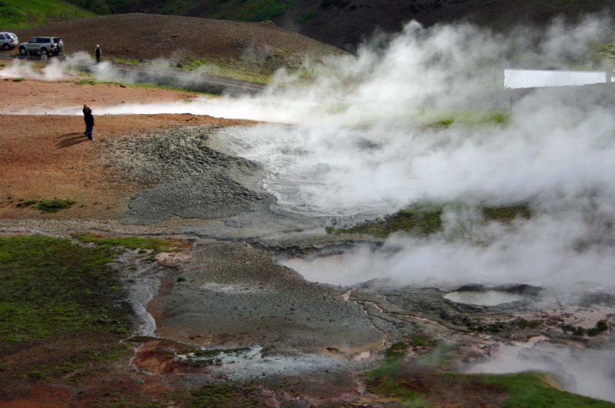
Figure 6 Hot springs on the outskirts of Hveragerði which formed after the earthquakes. Photo: Ágúst Gunnar Gylfason.

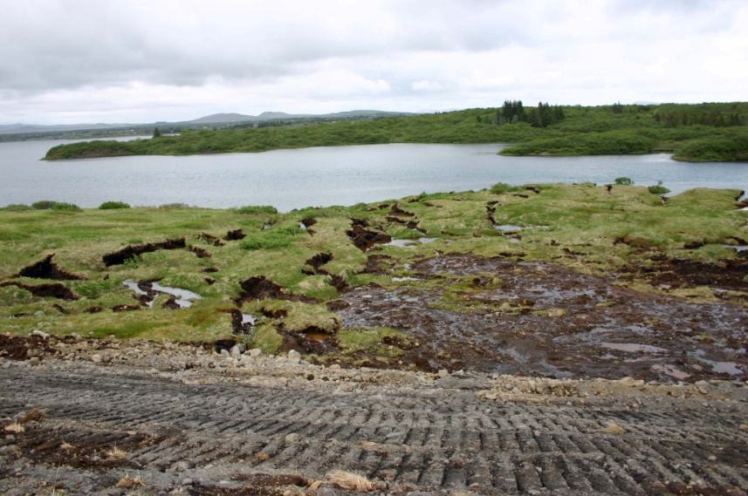
Figure 7 Liquefaction of soil about 10 km northeast of the epicentre of the earthquake. Photo: Ágúst Gunnar Gylfason.
Pandemic influenza plans
In 2005 there was a call for a national plan for pandemic influenza, the bird flu. The medical sector soon had a plan but then people realized that more was needed. A plan for a pandemic has to cover all aspects of society. We have to make sure society as a whole functions in such an event. The Department of Civil Protection and Emergency Management along with the State Epidemiologist worked together on the plan at the behest of the government. The State Epidemiologist was responsible for matters regarding the medical sector and the Department of Civil Protection and Emergency Management took on other aspects.
Table 1 shows a list of the main chapters in the plan which was signed and sealed in March of 2008. The plan has a purpose statement, a chapter on how it is activated and what the operational phases are and how our three phases correspond to the six phases defined by the World Health Organization. The Command structure is defined; there is a list of operational units and what the operational tasks are. The plan also includes a risk assessment and it also defines the communication structure during a pandemic. To name an example local doctor confer with their regional epidemiologist who in turn confers with the State Epidemiologist. District Commissioners work closely with the district epidemiologist and District Operational Commands. Major policy decisions are made jointly by the State Epidemiologist and representatives of the National Commissioner of Police, the Ministry of Health and the Ministry of Justice.
Table 1 The main chapters of the national contingency plan for pandemic influenza in Iceland.
Purpose statement
Activation of the plan and operational phases
Command structure
Operational units
Risk assessment
Operational tasks
Communication structure

The contingency plan for pandemic influenza covers such varied topics as banking and finance, failures in the infrastructure, distribution of medical supplies, food and other household goods and fuel (table 2). The plan is a general one for the nation as a whole so it defines structure and a methodology to tackle the work at hand. In general it delegates responsibility to individual sectors and stipulates that decisions be made as locally as possible.
Table 2 Topics covered in the national plan for pandemic influenza.
- Banking and finance  - Infrastructure  - Immunizations and medical supplies  - Distribution of supplies  - Prisons  - Dissemination of information  - Diagnosis and treatment of influenza patients  - Nursing patients at home  - Food production  - Handling of deceased | - Postal service  - Psychological aid  - Ambulance services  - Schools  - Refuse disposal and pickup  - Quarantines and limits to travel  - Animal husbandry  - Cabinet of ministers and ministries  - Security at medical facilities and other selected facilities

At the moment we are at alert level two out of three, the hazard phase because of the influenza A(H1N1). We are not however implementing all measures called for at that level because of the nature of the current epidemic.
The opportunity the current situation offers has however been seized to push through with writing up contingency plans for both government authorities and the 15 districts around the country. In both cases the structures of the will be identical to the national plan. Both the Department of Civil Protection and Emergency Management and the State Epidemiologist will provide input for these plans and as usual the Department of Civil Protection and Emergency Management will carry the editorial authority for these plans.

